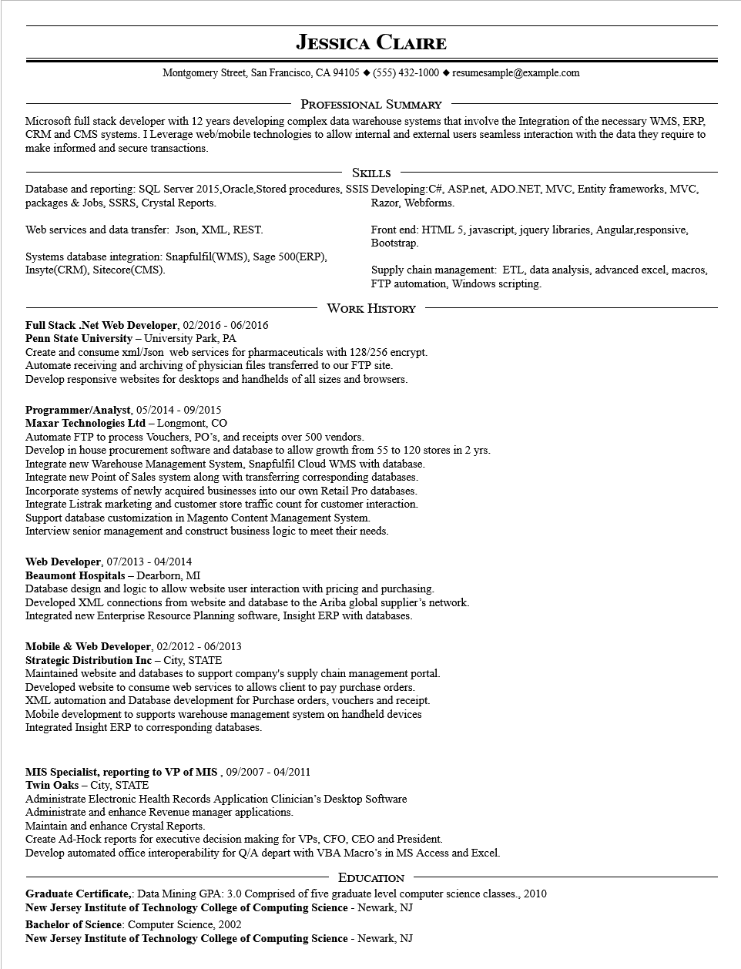
JESSICA CLAIRE
Montgomery Street, San Francisco, CA 94105 ♦ (555) 432-1000 resumesample@example.com
PROFESSIONAL SUMMARY
Microsoft full stack developer with 12 years developing complex data warehouse systems that involve the Integration of the necessary WMS, ERP, CRM and CMS systems. I Leverage web/mobile technologies to allow internal and external users seamless interaction with the data they require to make informed and secure transactions.
SKILLS
Database and reporting: SQL Server 2015,Oracle, Stored procedures, SSIS Developing:C#, ASP.net, ADO.NET, MVC, Entity frameworks, MVC, packages & Jobs, SSRS, Crystal Reports. Razor, Webforms.
Web services and data transfer: Json, XML, REST.
Systems database integration: Snapfulfil(WMS), Sage 500(ERP), Insyte(CRM), Sitecore(CMS).
Front end: HTML 5, javascript, jquery libraries, Angular,responsive, Bootstrap.
Supply chain management: ETL, data analysis, advanced excel, macros, FTP automation, Windows scripting.
WORK HISTORY
Full Stack .Net Web Developer, 02/2016 - 06/2016 Penn State University - University Park, PA
Create and consume xml/Json web services for pharmaceuticals with 128/256 encrypt. Automate receiving and archiving of physician files transferred to our FTP site. Develop responsive websites for desktops and handhelds of all sizes and browsers.
Programmer/Analyst, 05/2014 - 09/2015
Maxar Technologies Ltd - Longmont, CO
Automate FTP to process Vouchers, PO's, and receipts over 500 vendors.
Develop in house procurement software and database to allow growth from 55 to 120 stores in 2 yrs. Integrate new Warehouse Management System, Snapfulfil Cloud WMS with database. Integrate new Point of Sales system along with transferring corresponding databases. Incorporate systems of newly acquired businesses into our own Retail Pro databases. Integrate Listrak marketing and customer store traffic count for customer interaction. Support database customization in Magento Content Management System. Interview senior management and construct business logic to meet their needs.
Web Developer, 07/2013 - 04/2014
Beaumont Hospitals - Dearborn, MI
Database design and logic to allow website user interaction with pricing and purchasing. Developed XML connections from website and database to the Ariba global supplier's network. Integrated new Enterprise Resource Planning software, Insight ERP with databases.
Mobile & Web Developer, 02/2012 - 06/2013
Strategic Distribution Inc - City, STATE
Maintained website and databases to support company's supply chain management portal. Developed website to consume web services to allows client to pay purchase orders. XML automation and Database development for Purchase orders, vouchers and receipt. Mobile development to supports warehouse management system on handheld devices Integrated Insight ERP to corresponding databases.
MIS Specialist, reporting to VP of MIS, 09/2007 - 04/2011
Twin Oaks - City, STATE
Administrate Electronic Health Records Application Clinician's Desktop Software Administrate and enhance Revenue manager applications.
Maintain and enhance Crystal Reports.
Create Ad-Hock reports for executive decision making for VPs, CFO, CEO and President.
Develop automated office interoperability for Q/A depart with VBA Macro's in MS Access and Excel.
EDUCATION
Graduate Certificate,: Data Mining GPA: 3.0 Comprised of five graduate level computer science classes., 2010
New Jersey Institute of Technology College of Computing Science - Newark, NJ
Bachelor of Science: Computer Science, 2002
New Jersey Institute of Technology College of Computing Science - Newark, NJ

